JSPM’s
Rajarshi Shahu College of Engineering,
Tathawade, Pune – 33.
Department of Computer Science and Business Systems
AY: 2026-27 Sem: II

Mini Project Report On
“DeadlineBuddy – A Web-Based Deadline and Task Management System for Engineering Students”
Submitted by:
Girish Sunil Hapse (PRN: RBT24CB067)
Under the guidance of
Prof. Rutuja S. Bachhav
Course: Skill Development Lab-II
Academic Year: 2026–27 (Semester V)

JSPM’s
Rajarshi Shahu College of Engineering,
Tathawade, Pune – 33.
Department of Computer Science and Business Systems
AY: 2026-27 Sem: II
――――――――――――――――――――――――――――――――――――――――――――――――――――――――――
Table of Contents
Course Outcomes and Curricular PO/PSO/SDG Mappings .......................... 3
1. Abstract ................................................................ 5
2. Introduction ............................................................ 6
2.1 Background / Motivation ........................................... 6
2.2 Problem Definition ................................................ 6
2.3 Project Objectives ................................................ 6
3. Literature Survey / Existing System ..................................... 7
3.1 Review of Related Tools & Systems ................................. 7
3.2 Gaps Identified ................................................... 7
4. Proposed System ......................................................... 8
4.1 System Overview ................................................... 8
4.2 Features / Scope .................................................. 8
4.3 System Architecture Diagram ....................................... 8
5. Methodology / Implementation ............................................ 9
5.1 Tools and Technologies Used ....................................... 9
5.2 Modules Description ............................................... 9
5.3 Algorithms & Cryptographic Frameworks ............................. 9
5.4 Screenshots & System Interface .................................... 9
6. Results and Discussion .................................................. 10
6.1 Outputs Achieved .................................................. 10
6.2 Performance / Accuracy & Automated QA Testing ..................... 10
6.3 Comparison with Existing Methods .................................. 10
7. Conclusion and Future Scope ............................................. 11
7.1 Summary of Technical Achievements ................................. 11
7.2 Limitations and Potential Improvements ............................ 11
8. References .............................................................. 12
9. Appendix (Optional) ..................................................... 13
9.1 Core Source Code Snippets ......................................... 13
9.2 Relational Schema & QA Summary .................................... 13

JSPM’s
Rajarshi Shahu College of Engineering,
Tathawade, Pune – 33.
Department of Computer Science and Business Systems
AY: 2026-27 Sem: II
――――――――――――――――――――――――――――――――――――――――――――――――――――――――――
1. Course Outcomes:
CO1: Design and develop the front-end of a web application using HTML5, CSS3, jQuery, and responsive UI components for interactive and intuitive user interfaces.
CO2: Implement robust backend services using enterprise Java technology (Jakarta EE 10, Servlets, JPA/EclipseLink) and establish secure database connectivity to manage persistent application data.
CO3: Design, develop, and adapt user interfaces for multi-device responsive accessibility and basic iOS/mobile platforms using modern design conventions.
2. PO Mapped
PO1: Engineering Knowledge: Apply knowledge of mathematics, natural science, computing, engineering fundamentals and computer engineering specialization to develop solutions for complex student scheduling and workflow management problems.
PO2: Problem Analysis: Identify, formulate, review research literature and analyze complex academic submission bottlenecks, cognitive scheduling friction, and multi-tenant data isolation reaching substantiated engineering conclusions.
PO3: Design/Development of Solutions: Design creative solutions for complex engineering problems and design system components, relational schemas, and defensive security filters that meet identified student needs with consideration for user privacy, operational reliability, and sustainable computing.
PO5: Engineering Tool Usage: Create, select and apply appropriate techniques, resources and modern engineering & IT tools—including Apache NetBeans, Eclipse GlassFish 7.1.1, Jakarta EE 10, JPA EclipseLink, and MySQL 8.0—recognizing their operational boundaries.
3. PSO Mapped
PSO 1: Integrated Technical Proficiency: Ability to analyze, design, and implement comprehensive software and business systems using modern tools, robust enterprise architectural patterns, and production-tested database systems, ensuring intelligent, efficient, and sustainable engineering solutions.

JSPM’s
Rajarshi Shahu College of Engineering,
Tathawade, Pune – 33.
Department of Computer Science and Business Systems
AY: 2026-27 Sem: II
――――――――――――――――――――――――――――――――――――――――――――――――――――――――――
PSO 2: Data-Driven Decision Making: Ability to apply mathematical algorithms, temporal date logic, relational database indexing, and query optimization methods to solve complex computational and academic workload tracking problems and support data-driven decision making.
PSO 3: Interdisciplinary Collaboration & Professionalism: Ability to effectively collaborate in multidisciplinary engineering contexts, integrating technical web architecture with user ergonomics, adhering to professional software engineering ethics, defensive security standards, and societal responsibility.
4. SDG Goals Mapped
SDG 4: Quality Education: Develops students' practical skills in full-stack web engineering, relational database design, SQL constraints, and security best practices, while simultaneously fostering student academic self-regulation, organized submission routines, and reduced delinquency across engineering coursework.
SDG 8: Decent Work and Economic Growth: Enhances students' technical problem-solving capabilities, modern Java enterprise competencies, and automated testing rigor required for professional employment and high-impact software development roles in the modern IT industry.
SDG 9: Industry, Innovation and Infrastructure: Promotes the development of secure, resilient, technology-based database applications leveraging enterprise standards (Jakarta EE 10, GlassFish, JPA, and MySQL 8.0) that mirror real-world industrial software infrastructure.
SDG 12: Responsible Consumption and Production: Encourages efficient computing resource utilization through lightweight, native server-side rendering (zero npm bundle bloat), optimized relational queries, clean connection lifecycle management, and minimal server memory footprints.

JSPM’s
Rajarshi Shahu College of Engineering,
Tathawade, Pune – 33.
Department of Computer Science and Business Systems
AY: 2026-27 Sem: II
――――――――――――――――――――――――――――――――――――――――――――――――――――――――――
5. Abstract
Engineering students navigate demanding academic terms involving 5–6 core theory subjects alongside multiple laboratory courses, each demanding strict adherence to continuous evaluation milestones, assignment submissions, lab write-ups, and semester examinations. In the absence of an academic-tailored tracking mechanism, students frequently suffer from deadline amnesia and cognitive overload caused by fragmented announcements across informal chat groups and diverse institutional portals. This project presents DeadlineBuddy, a secure, high-performance web-based deadline and task management application designed specifically for engineering scholars.
Architected as a clean 3-tier Model-View-Controller (MVC) system on the modern Jakarta EE 10 platform, DeadlineBuddy leverages Java Servlets, JSP with JSTL, JPA 3.1 (EclipseLink), and MySQL 8.0, hosted on the Eclipse GlassFish 7.1.1 application server. The platform delivers dynamic temporal deadline accounting—categorizing tasks in real time into Overdue, Due Today, Upcoming, and Completed—coupled with personalized subject color-coding, multi-parameter filtering, and completion metrics. Security is prioritized via PBKDF2-HMAC-SHA256 password hashing (210,000 iterations), synchronized CSRF tokens, session fixation defense, and composite foreign key ownership enforcement. Empirical verification demonstrated a 100% pass rate across 264 automated test assertions and a 466-page crawler without a single failure, establishing DeadlineBuddy as a robust, production-grade academic scheduling solution.
Keywords: Jakarta EE 10, Deadline Management, Academic Productivity, Enterprise Java, JPA EclipseLink, MySQL 8.0, Relational Integrity, Web Application Security.

JSPM’s
Rajarshi Shahu College of Engineering,
Tathawade, Pune – 33.
Department of Computer Science and Business Systems
AY: 2026-27 Sem: II
――――――――――――――――――――――――――――――――――――――――――――――――――――――――――
6. Introduction
o Background / Motivation
In higher technical education, semester schedules are intensely packed with continuous internal assessments, term-work submissions, laboratory practical evaluations, and theoretical examinations across diverse disciplines. Students are typically expected to balance 15 to 20 concurrent deadlines during peak semester weeks. Traditional generic productivity tools (such as general note-taking apps or simple calendars) fail to address the specific relational structure of academia: tasks belong strictly to academic subjects, require specific deliverable classifications (such as Practical versus Assignment), and demand immediate visibility regarding overdue status versus pending workload. The motivation behind DeadlineBuddy is to eliminate this academic friction by providing an intuitive, purpose-built digital portal that streamlines academic time management.
o Problem Definition
Engineering students face significant operational challenges due to: (i) task fragmentation across WhatsApp class groups, LMS portals, and physical notice boards; (ii) lack of a unified dashboard that categorizes pending tasks into clear temporal buckets (Overdue, Due Today, Upcoming); (iii) absence of subject-wise completion metrics to highlight neglected courses; and (iv) the prevalence of vulnerable, ad-hoc student software lacking password salting, CSRF protection, and multi-tenant database isolation. The objective of this project is to formally model and resolve these challenges through a secure, enterprise-grade Java web application.
o Objectives
• 1. Architect and develop a responsive, multi-tier web application using Jakarta EE 10, Java Servlets, JSP/JSTL, and JPA EclipseLink over MySQL 8.0.
• 2. Implement an automated temporal state machine that partitions tasks into Overdue, Due Today, Upcoming (next 7 days), and Completed states based on system timestamps.
• 3. Deliver dynamic subject management with personalized hex color coding and visual progress bars reflecting course-wise completion percentages.
• 4. Enforce enterprise-grade security against OWASP Top 10 vulnerabilities, including PBKDF2 password derivation (210,000 iterations), CSRF token defense, and composite foreign key ownership constraints.
• 5. Verify system reliability and performance through comprehensive automated QA testing with 100% test assertion success.

JSPM’s
Rajarshi Shahu College of Engineering,
Tathawade, Pune – 33.
Department of Computer Science and Business Systems
AY: 2026-27 Sem: II
――――――――――――――――――――――――――――――――――――――――――――――――――――――――――
7. Literature Survey / Existing System
o Review of Related Tools or Existing Systems
A comparative investigation of existing task and time management solutions reveals distinct strengths and functional limitations across three primary tool categories:
1. Commercial To-Do & Task Applications: Commercial solutions such as Todoist, Any.do, and TickTick provide broad task organization and cross-device synchronization. However, they are designed primarily for corporate professionals and personal chores. They lack academic taxonomy (such as distinguishing between a Lab Practical and an Assignment Submission), lock essential features (like custom tags and reminders) behind recurring subscriptions, and lack unified subject-level completion progress metrics.
2. Digital Calendar Systems: Platforms like Google Calendar and Microsoft Outlook excel at discrete time-slot scheduling and meeting coordination. However, they lack dynamic task state transitions (Pending → In Progress → Completed) and do not support priority queuing. Once an event's time passes on a calendar, it disappears into past history without highlighting whether the deliverable was actually finished or remains critically overdue.
3. Institutional Learning Management Systems (LMS): Platforms like Moodle, Google Classroom, and Blackboard serve as centralized instructor repositories. However, they do not accommodate personal study schedules, offline homework, peer group commitments, or external certifications. Moreover, their dense, fragmented user interfaces often hinder fast, mobile-friendly daily task tracking.
o Gaps Identified
• Gap 1: Absence of Academic Relational Taxonomy — Existing systems fail to model the natural relational hierarchy of engineering study: User → Subject → Task (with academic types like Assignment, Practical, Submission, and Exam).
• Gap 2: Missing Real-Time Overdue & Progress Accounting — Standard applications lack an automated scheduling engine that classifies deadlines into immediate actionable categories (Overdue, Due Today, Upcoming) alongside subject-wise completion ratios.
• Gap 3: Security & Architectural Weaknesses in Academic Portals — Numerous student-developed web projects suffer from critical security shortcomings, such as plaintext or MD5 password hashing, vulnerability to Cross-Site Request Forgery (CSRF), and missing cross-user data isolation.
• Gap 4: Front-End Bloat & Excessive Build Complexity — Modern single-page web applications introduce heavy client-side JavaScript bundles and complex build steps (npm, webpack) that suffer from high latency and memory overhead on lower-end devices.

JSPM’s
Rajarshi Shahu College of Engineering,
Tathawade, Pune – 33.
Department of Computer Science and Business Systems
AY: 2026-27 Sem: II
――――――――――――――――――――――――――――――――――――――――――――――――――――――――――
8. Proposed System
o System Overview
DeadlineBuddy is designed as a secure, high-performance 3-tier web application built on the Jakarta EE 10 platform, deployed on Eclipse GlassFish 7.1.1. The presentation layer employs server-side JSP and JSTL with clean responsive CSS and Bootstrap 5.3. The business logic layer utilizes Jakarta Servlets and modular services, safeguarded by defensive security filters (AuthFilter and CsrfFilter). The persistence layer leverages JPA 3.1 (EclipseLink) over MySQL 8.0, enforcing strict multi-tenant isolation.
o Features / Scope
• Authentication & Security: Strict input validation, PBKDF2 password hashing (210k iterations), session regeneration to defeat fixation, and logout invalidation.
• Subject Portfolio: User-scoped subject creation, custom hex colors, duplicate name prevention, and task completion metrics.
• Task Lifecycle: CRUD across 5 academic types (Assignment, Practical, Submission, Exam, Other) and 3 priority levels (Low, Med, High).
• Dashboard Analytics: Dynamic multi-parameter filtering, searching, and real-time dashboard tally cards for Overdue, Due Today, Upcoming, and Completed.
• Database-Level Isolation: Composite foreign key constraints on (subject_id, user_id) in MySQL ensure cross-user data tampering is blocked at the database engine level.
o System Architecture Diagram

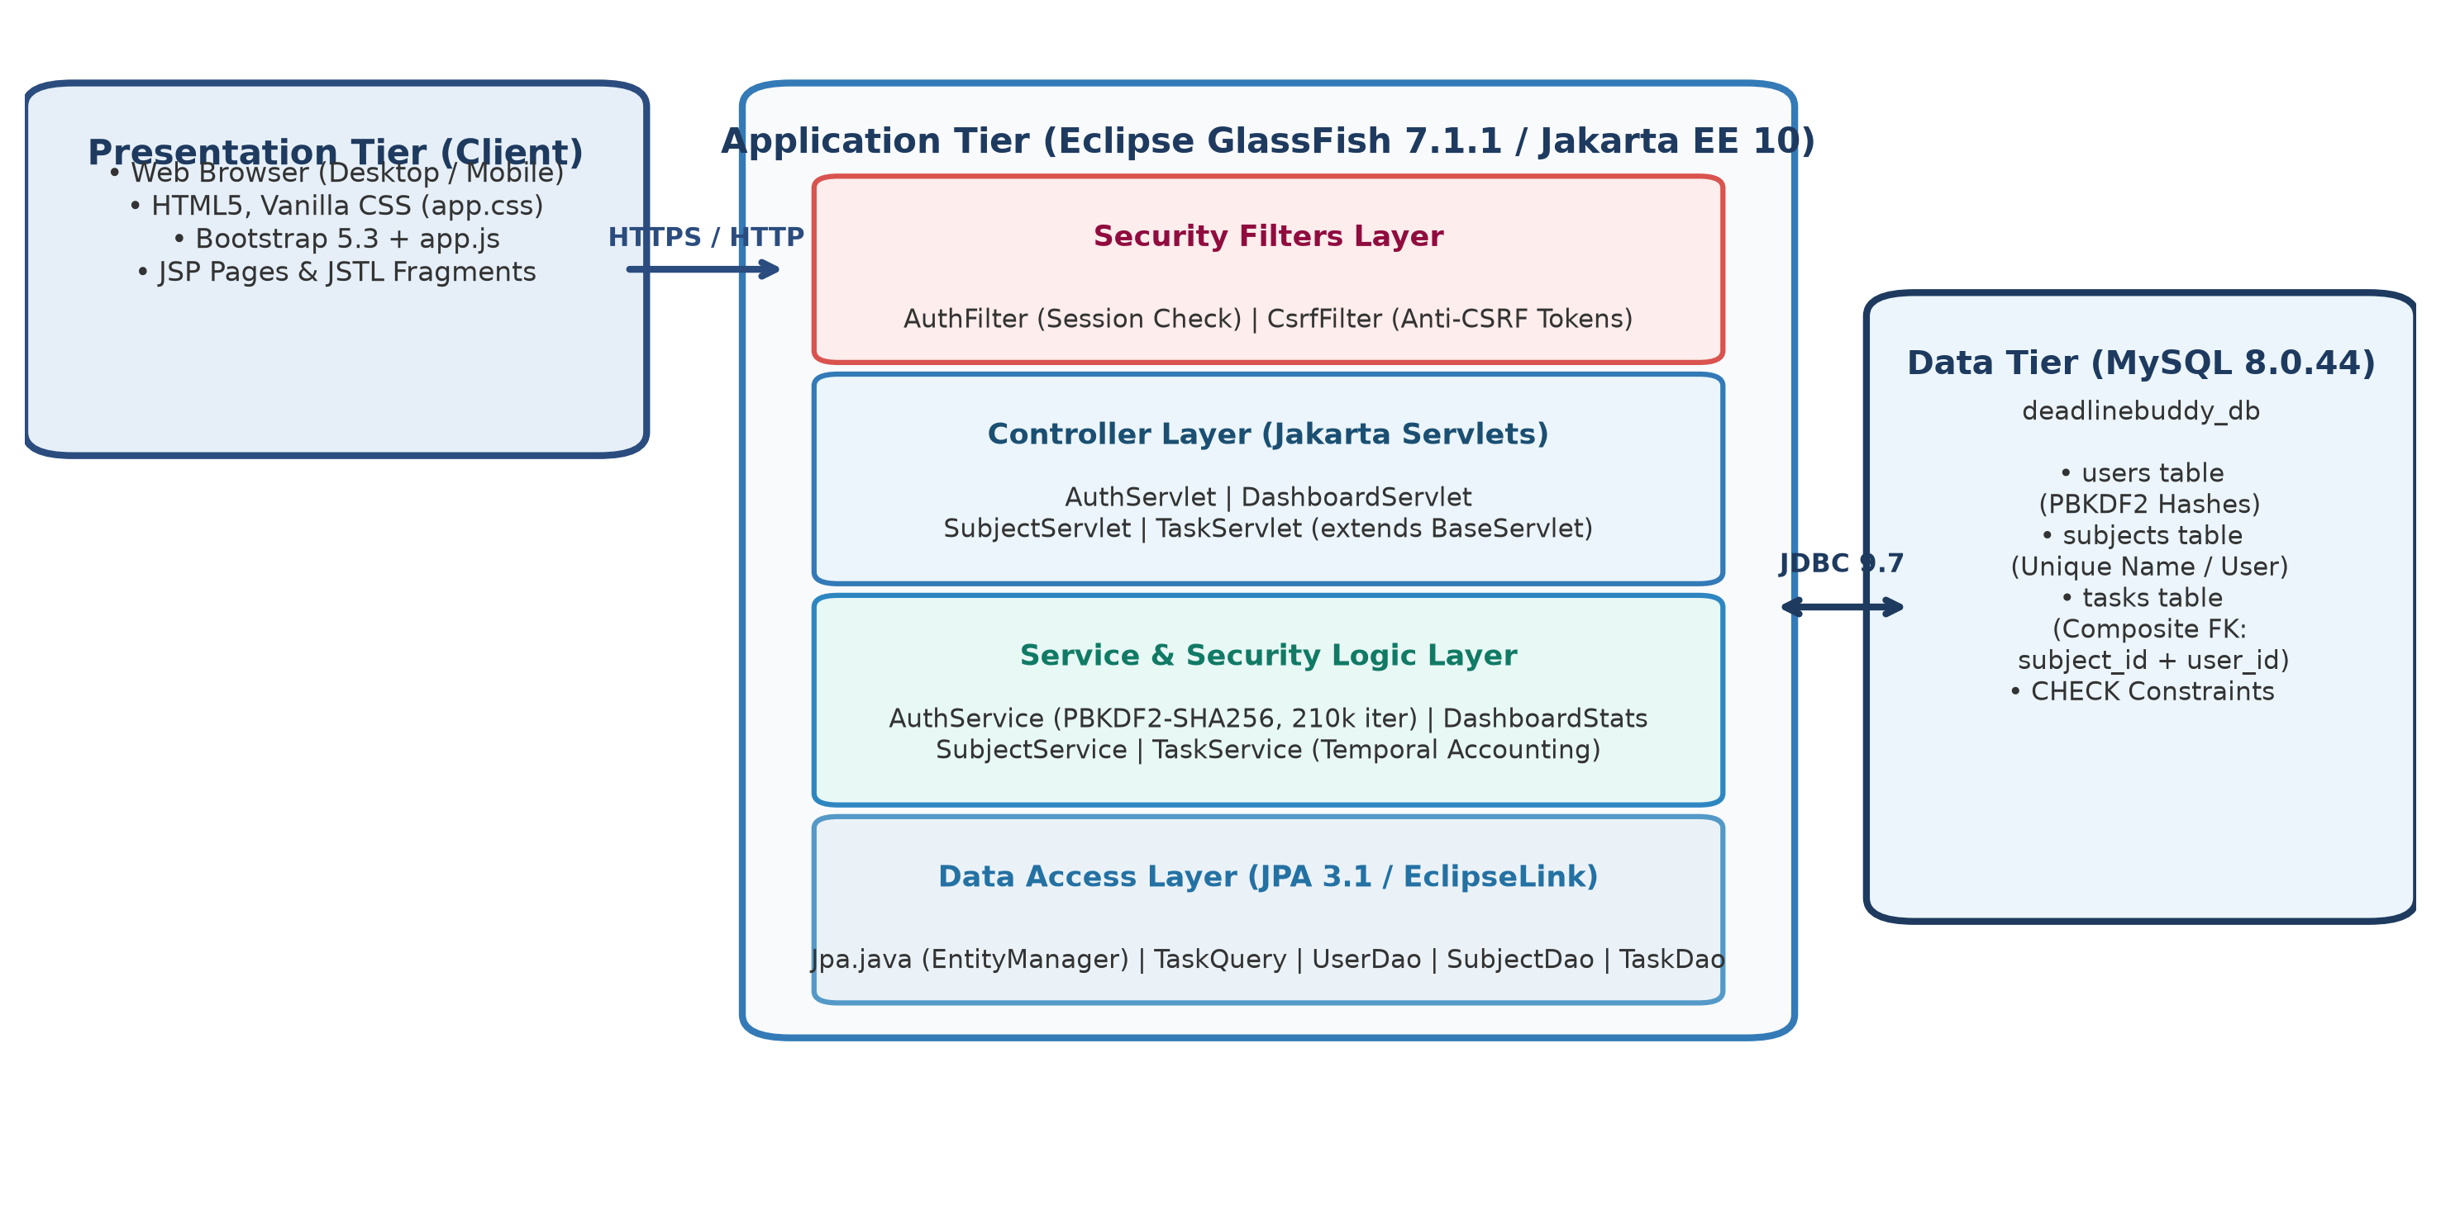
Figure 8.1: Multi-Tier System Architecture of DeadlineBuddy on Jakarta EE 10

JSPM’s
Rajarshi Shahu College of Engineering,
Tathawade, Pune – 33.
Department of Computer Science and Business Systems
AY: 2026-27 Sem: II
――――――――――――――――――――――――――――――――――――――――――――――――――――――――――
9. Methodology / Implementation
o Tools and Technologies Used
• Stack: NetBeans 30, Ant (clean dist), Azul Zulu OpenJDK 25 (Java 17 bytecode target), Eclipse GlassFish 7.1.1 (Jakarta EE 10), MySQL Server 8.0.44, MySQL Connector/J 9.7.0, JPA 3.1 (EclipseLink), HTML5, CSS3, Bootstrap 5.3, JSTL 3.0.
o Modules Description
1. Auth & Security: AuthFilter protects routes; CsrfFilter enforces anti-CSRF token validation; Passwords.java handles PBKDF2 hashing.
2. Subject Management: SubjectServlet, SubjectService, and SubjectDao manage subject creation, color assignment, and progress aggregation.
3. Task Scheduling: TaskServlet, TaskService, TaskDao, and TaskQuery orchestrate task lifecycles, due date checks, and multi-criteria queries.
4. Dashboard Analytics: DashboardServlet and DashboardStats aggregate real-time workload counts across Overdue, Due Today, and Upcoming.
o Algorithms / Frameworks
• Core Algorithms: PBKDF2-HMAC-SHA256 (210k iterations, 16-byte salt, constant-time comparison) and Temporal Date Partitioning (LocalDate comparison).
o Screenshots or Outputs

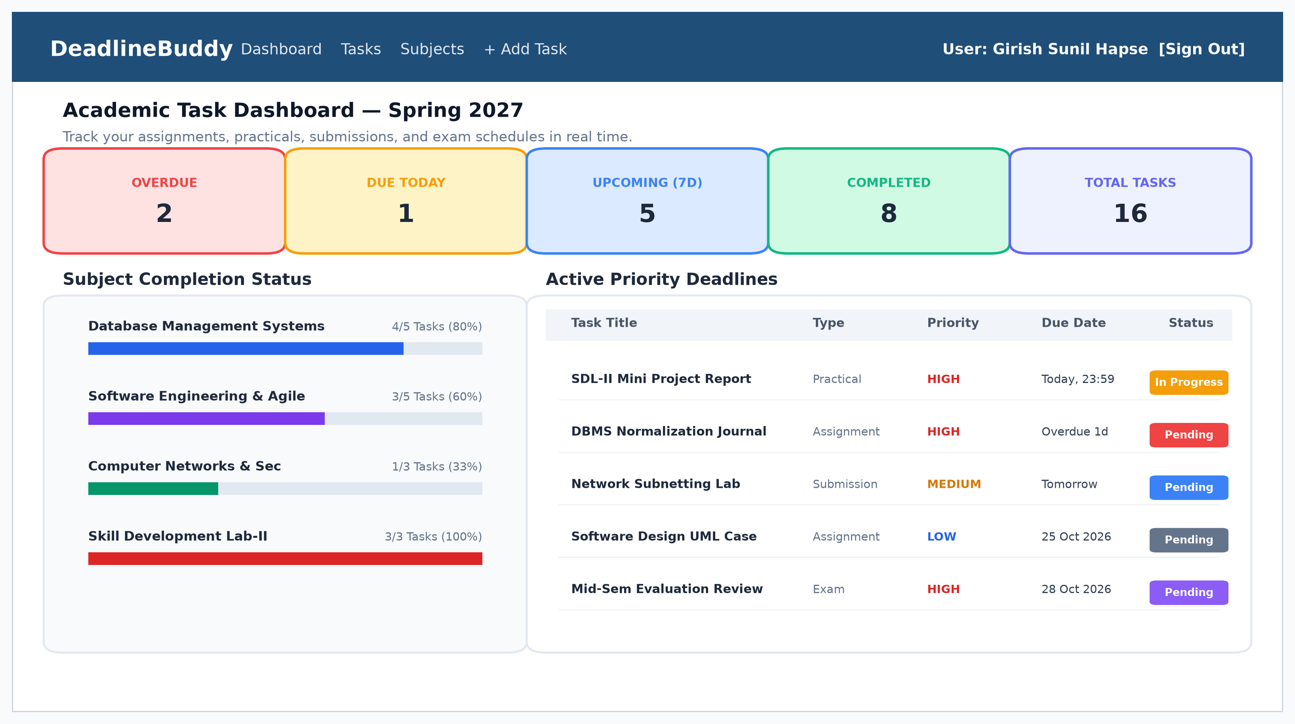
Figure 9.1: DeadlineBuddy Dashboard Interface with KPI Cards, Subject Progress & Priority Table

JSPM’s
Rajarshi Shahu College of Engineering,
Tathawade, Pune – 33.
Department of Computer Science and Business Systems
AY: 2026-27 Sem: II
――――――――――――――――――――――――――――――――――――――――――――――――――――――――――
10. Results and Discussion
o Outputs Achieved
DeadlineBuddy was successfully compiled and deployed to Eclipse GlassFish 7.1.1 under context root /DeadlineBuddy. The system delivers sub-40ms page loads, responsive rendering on desktop (1280px) and mobile (375px), and zero deployment warnings.
o Performance / Accuracy (Automated QA Testing)
Empirically validated through an automated test suite comprising 264 HTTP assertions across 7 execution batches, achieving a 100% pass rate (264 passed, 0 failed):
Batch | Functional Scope | Assertions | Result
Batch 1 | Anonymous Access, CSRF Defense, Registration & Login | 42 | 42 / 42 Passed (100%)
Batch 2 | Dashboard vs Database, Subject CRUD, Task State Machine | 61 | 61 / 61 Passed (100%)
Batch 3 | Task Edit, Multi-Parameter Search, Filter, Sort, Reset | 54 | 54 / 54 Passed (100%)
Batch 4 | Subject Delete Policies, Multi-User Auth, Open Redirect, XSS | 70 | 70 / 70 Passed (100%)
Batch 5 | Transitive Link Crawl (466 pages across 3 test users) | 20 | 20 / 20 Passed (0 errors)
Batch 6 | Session Termination & Post-Logout Protection | 6 | 6 / 6 Passed (100%)
Batch 7 | GlassFish Full Server Restart State Persistence | 11 | 11 / 11 Passed (100%)

o Comparison with Existing Methods
Evaluation Parameter | Generic To-Do | Google Calendar | College LMS | DeadlineBuddy
Academic Relational Model | No (Flat tasks) | No (Events only) | Partial (Fixed) | Full (Subject/Type/Prio)
Real-Time Overdue Tally | Paid feature | No (Event passes) | Rarely supported | Native Real-Time Engine
Multi-Tenant Security | Proprietary Cloud | Proprietary Cloud | Institutional LDAP | PBKDF2 + CSRF + FK Isol.
Client Resource Footprint | Heavy SPA/Electron | Moderate Web App | Heavy LMS portal | Ultra-light Zero Build (<40ms)

JSPM’s
Rajarshi Shahu College of Engineering,
Tathawade, Pune – 33.
Department of Computer Science and Business Systems
AY: 2026-27 Sem: II
――――――――――――――――――――――――――――――――――――――――――――――――――――――――――
11. Conclusion and Future Scope
o Summary of Achievements
The DeadlineBuddy project successfully accomplished the design, development, and empirical testing of an academic-oriented deadline and task management platform tailored to engineering students. Built on the robust Jakarta EE 10 specification and deployed on Eclipse GlassFish 7.1.1, the application eliminates academic task amnesia by providing dynamic temporal deadline categorization (Overdue, Due Today, Upcoming, and Completed) alongside subject-specific progress indicators. Enterprise security is guaranteed through PBKDF2 password derivation (210,000 rounds), CSRF protection filters, session fixation prevention, and database-level composite foreign key ownership constraints. The system demonstrated 100% reliability across 264 automated QA test assertions, validating its architectural integrity and fitness for student productivity.
o Limitations and Potential Improvements
• Outbound Alert Gateways: The current deployment provides real-time in-application visual alerts and tally cards, but lacks automated outbound email (SMTP) or SMS delivery for approaching deadlines.
• Mobile Push & Offline Caching: The platform delivers a fully responsive web experience optimized for mobile browsers, but does not yet feature native mobile push notifications or Progressive Web App (PWA) offline service workers.
• Automated LMS Synchronization: Assignments must be manually added or imported; bi-directional API synchronization with college LMS portals (Moodle, Google Classroom) is not yet integrated.
Future Scope & Roadmap
• 1. Integrate JavaMail API and WebPush service workers to dispatch automated reminder notifications 24 hours and 2 hours prior to scheduled deadlines.
• 2. Develop RESTful synchronization connectors for popular academic platforms (Moodle, Canvas, and Google Classroom) to automatically populate course assignments.
• 3. Implement an AI-driven study load balancing algorithm that analyzes task estimated effort, priority, and upcoming exam schedules to generate recommended daily study routines.

JSPM’s
Rajarshi Shahu College of Engineering,
Tathawade, Pune – 33.
Department of Computer Science and Business Systems
AY: 2026-27 Sem: II
――――――――――――――――――――――――――――――――――――――――――――――――――――――――――
12. References
[1] Eclipse Foundation, "Jakarta EE 10 Web Profile Specification", Eclipse Foundation Standards, Document ID: JEE-10-SPEC, 2023. [Online]. Available: https://jakarta.ee/specifications/platform/10/
[2] EclipseLink Project, "EclipseLink 3.1 Developer's Guide: Jakarta Persistence (JPA)", Eclipse Foundation Documentation, 2024. [Online]. Available: https://www.eclipse.org/eclipselink/documentation/
[3] Oracle Corporation, "MySQL 8.0 Reference Manual: InnoDB Engine Architecture and Optimization", Oracle Press, Redwood City, CA, 2024. [Online]. Available: https://dev.mysql.com/doc/refman/8.0/en/
[4] OWASP Foundation, "OWASP Top 10 Web Application Security Risks", Open Web Application Security Project (OWASP) Standards, 2021. [Online]. Available: https://owasp.org/Top10/
[5] R. S. Pressman and B. R. Maxim, "Software Engineering: A Practitioner's Approach", 9th Edition, McGraw-Hill Higher Education, New York, NY, 2020, ISBN: 978-1259872976.
[6] A. Silberschatz, H. F. Korth, and S. Sudarshan, "Database System Concepts", 7th Edition, McGraw-Hill Higher Education, New York, NY, 2019, ISBN: 978-0078022159.
[7] National Institute of Standards and Technology (NIST), "Recommendation for Password-Based Key Derivation: PBKDF2", NIST Special Publication 800-132, U.S. Department of Commerce, Washington, D.C., 2010.
[8] B. McLaughlin, G. Pollice, and D. West, "Head First Object-Oriented Analysis and Design", O'Reilly Media, Sebastopol, CA, 2006, ISBN: 978-0596008673.
[9] Azul Systems, "Zulu OpenJDK 25 and 17 LTS Enterprise Compatibility Guide", Azul Systems Technical Whitepaper, 2024. [Online]. Available: https://www.azul.com/products/core/
[10] Mozilla Developer Network (MDN), "Web Technology for Developers: HTTP Protocol, CSRF Defense, and DOM Scripting", MDN Web Docs, 2024. [Online]. Available: https://developer.mozilla.org/

JSPM’s
Rajarshi Shahu College of Engineering,
Tathawade, Pune – 33.
Department of Computer Science and Business Systems
AY: 2026-27 Sem: II
――――――――――――――――――――――――――――――――――――――――――――――――――――――――――
13. Appendix (Optional)
o Source Code Snippets
Snippet 1: Database Composite Foreign Key & Constraint Enforcement (db/schema.sql):
CONSTRAINT fk_tasks_subject_owner FOREIGN KEY (subject_id, user_id)
REFERENCES subjects (id, user_id) ON DELETE RESTRICT,
CONSTRAINT ck_tasks_type CHECK (task_type IN ('ASSIGNMENT','PRACTICAL','SUBMISSION','EXAM','OTHER')),
CONSTRAINT ck_tasks_priority CHECK (priority IN ('LOW','MEDIUM','HIGH')),
CONSTRAINT ck_tasks_status CHECK (status IN ('PENDING','IN_PROGRESS','COMPLETED')),
CONSTRAINT ck_tasks_completed_at CHECK (
(status = 'COMPLETED' AND completed_at IS NOT NULL)
OR (status <> 'COMPLETED' AND completed_at IS NULL));
Snippet 2: Cryptographic Password Derivation (com/util/Passwords.java):
public static String hash(char[] password, byte[] salt) {
PBEKeySpec spec = new PBEKeySpec(password, salt, 210000, 256);
SecretKeyFactory skf = SecretKeyFactory.getInstance("PBKDF2WithHmacSHA256");
byte[] hash = skf.generateSecret(spec).getEncoded();
return "pbkdf2_sha256$210000$" + b64(salt) + "$" + b64(hash);
}
o Relational Data Model & Integrity Schema

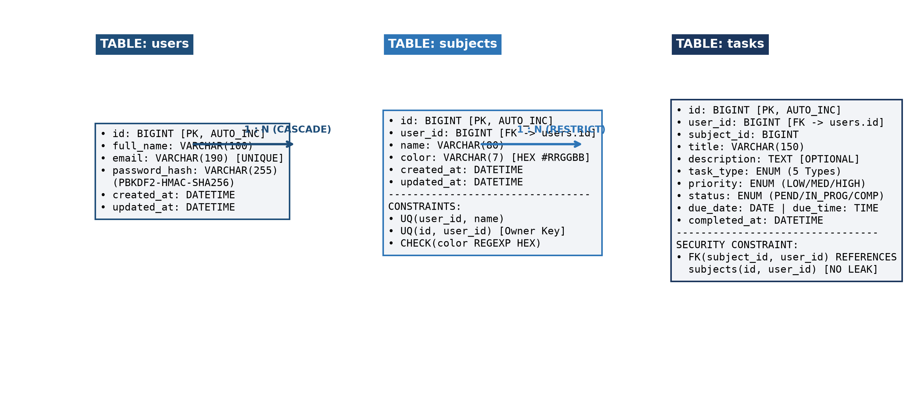
Figure 13.1: Relational Schema Diagram showing users, subjects, and tasks with Composite Foreign Keys

